Sequence diagram – PregnancyBehaviour.getAction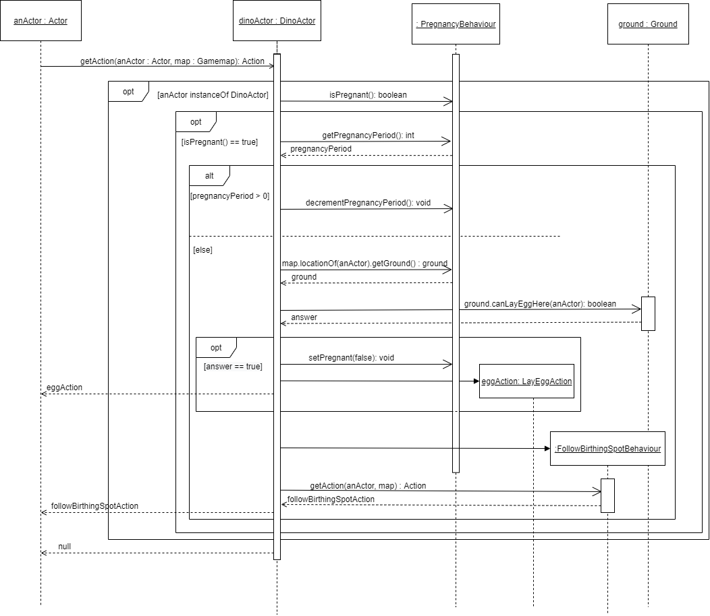

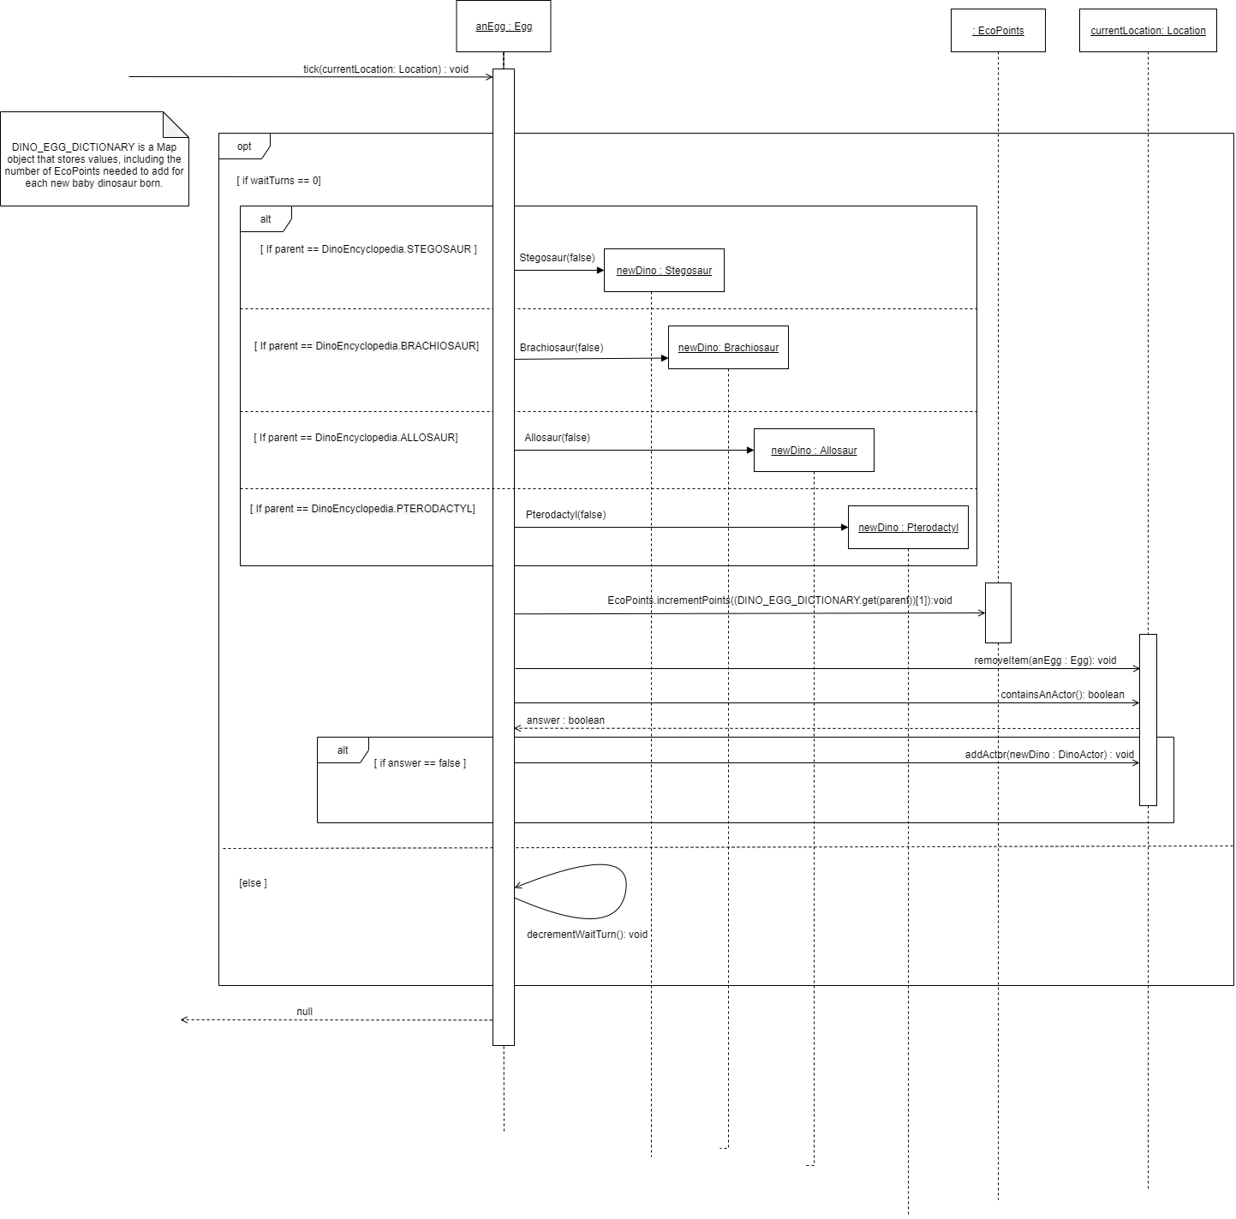Sequence diagram – Egg’s tick method

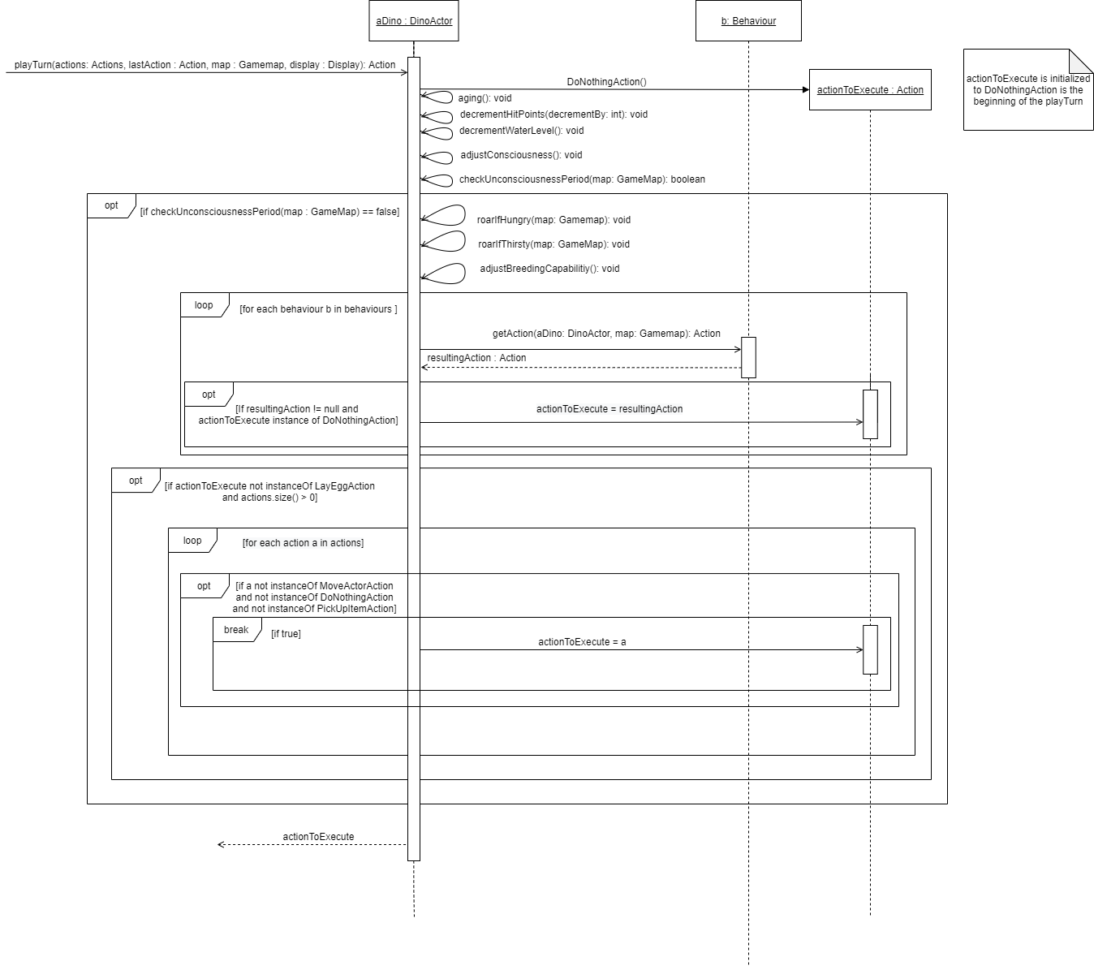Sequence diagram – DinoActor’s playTurn method

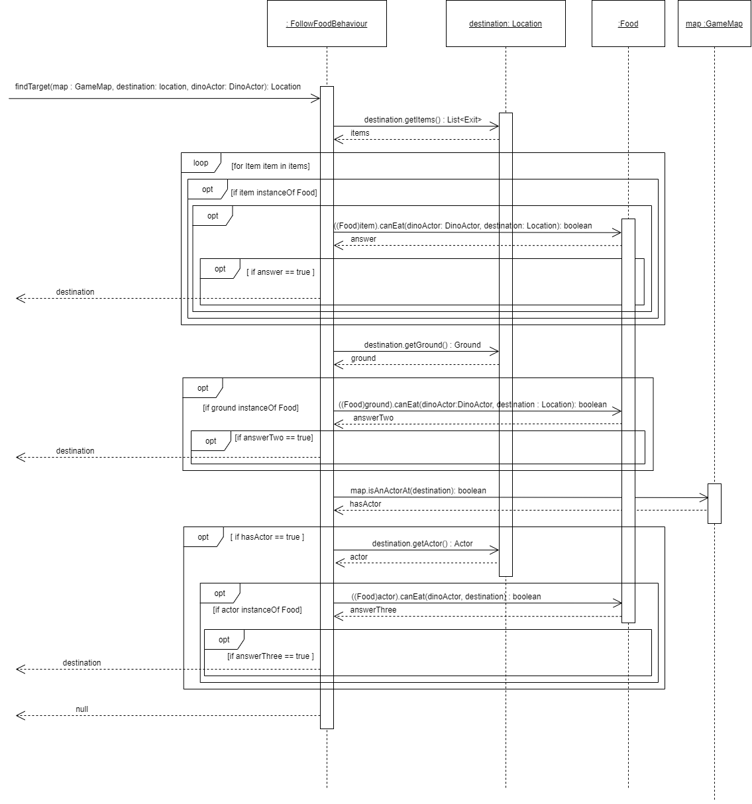Interaction diagram – FollowFoodBehaviour.getAction